**EXP NO: 04**

**DATE: 13-04-24**

**Aim:**

Create a simple cloud software application for Library book reservation system for SIMATS library using any Cloud Service Provider to demonstrate SaaS include the necessary fields such as Title of the book, author, publications, Year, edition, no of copies, Rack no, status (taken/returned) etc.

**Implementation:**

**1. Go to Zoho.com and login/signup**

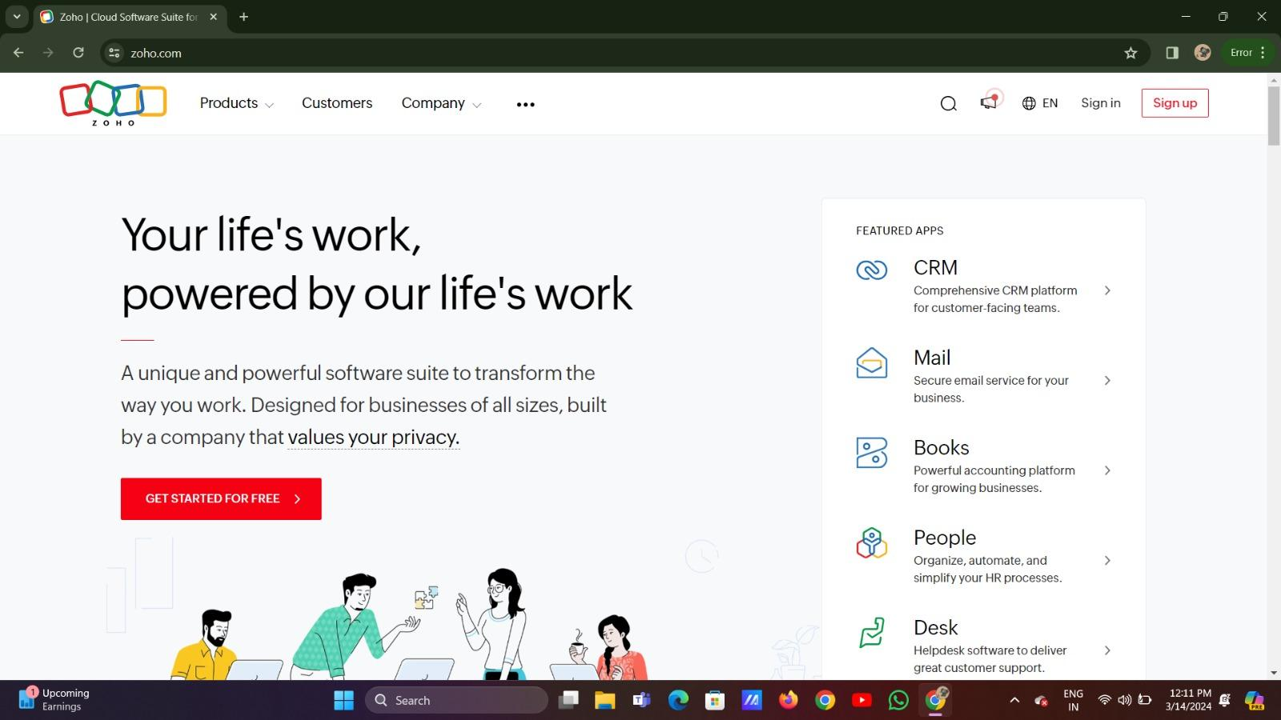

**2. Go to Creator**

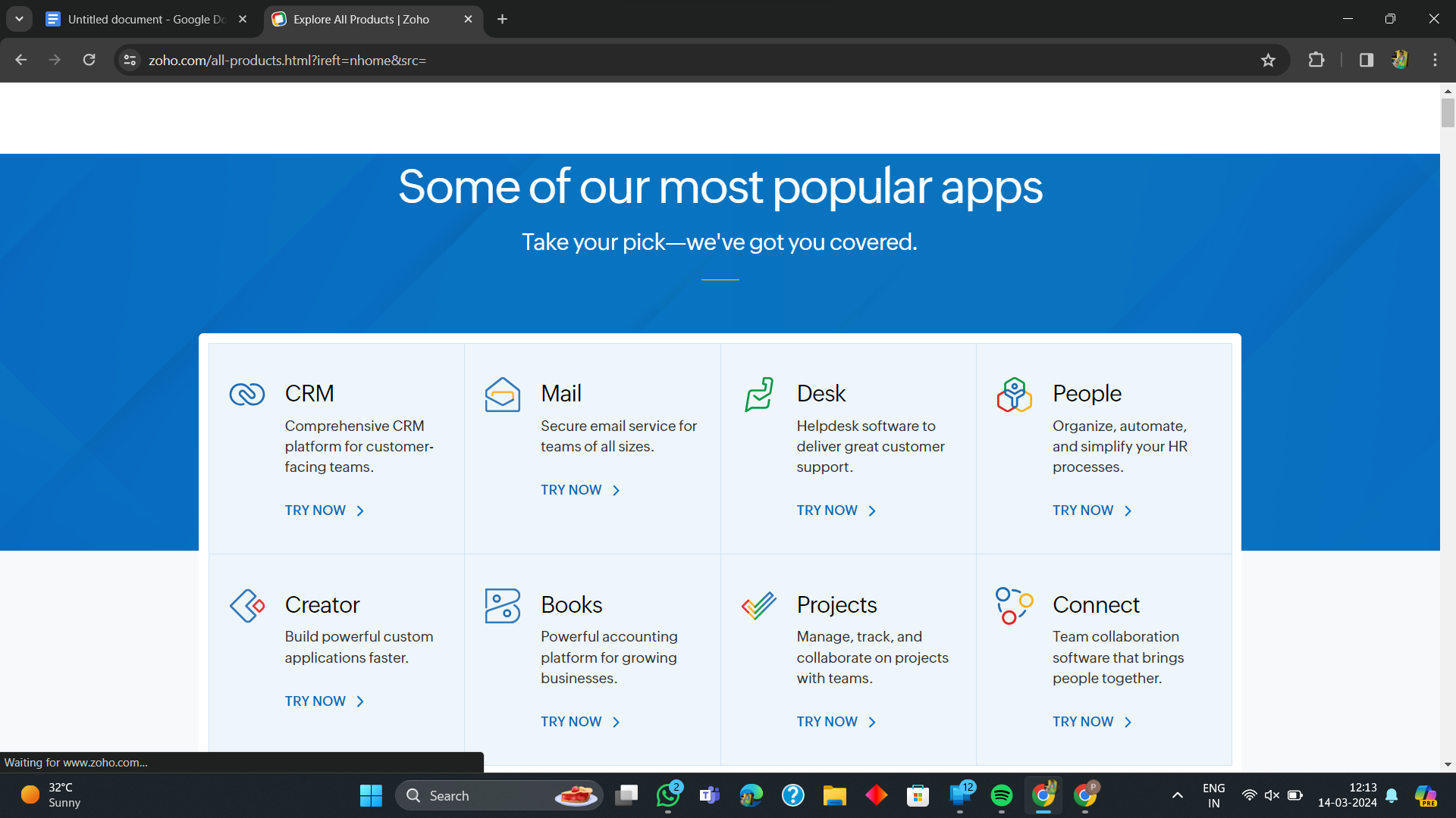

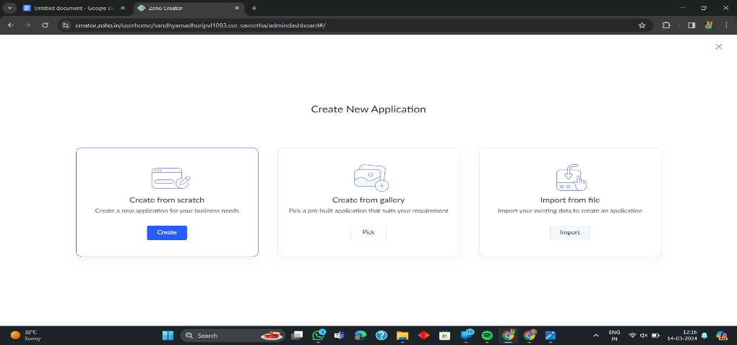**3. Create A New Application**

**4. Given Application Name**

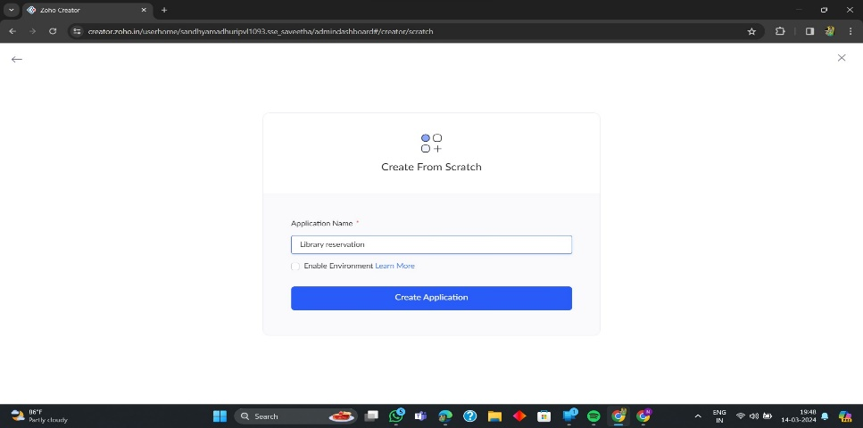

**5. Create New Form**

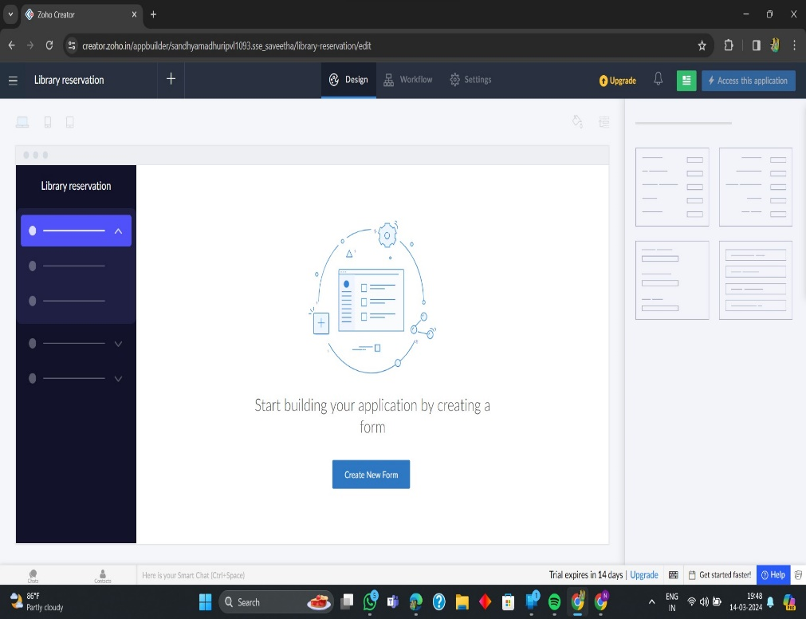

**6. Select Form and Give Name**

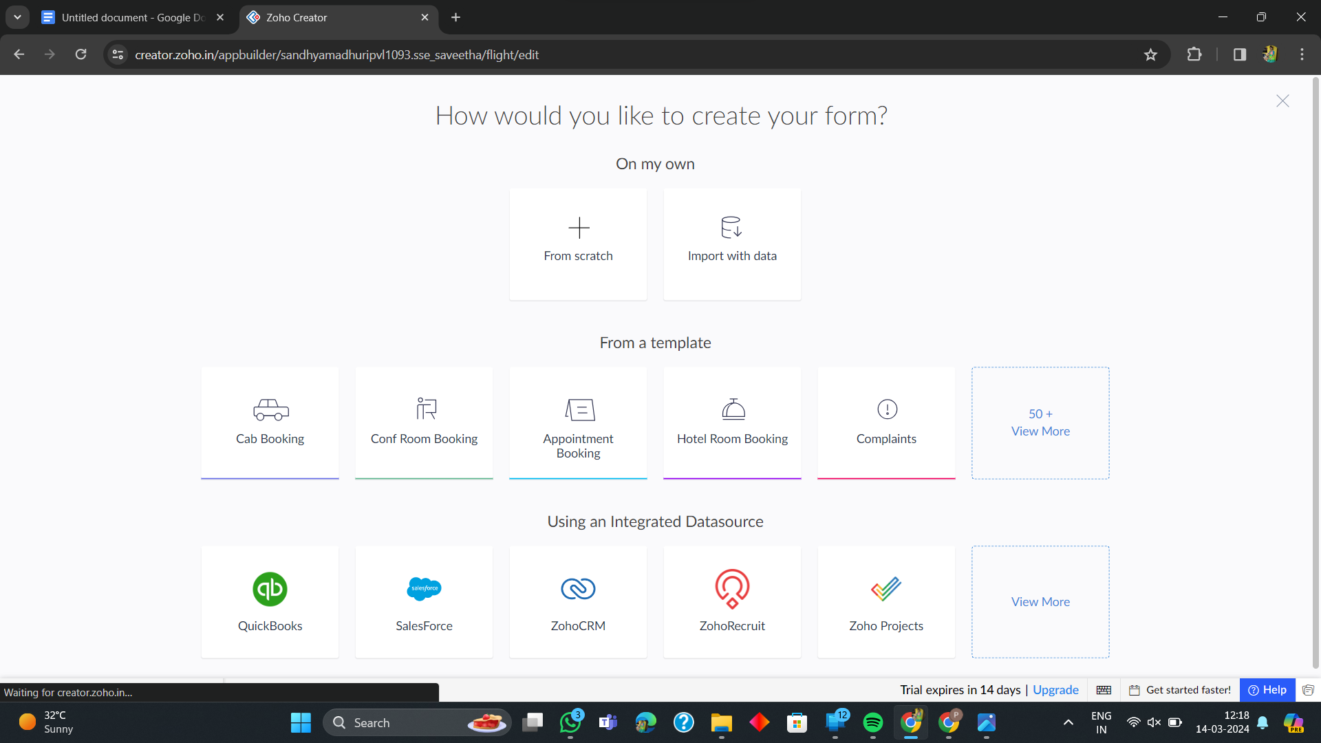

**7. Create from scratch**

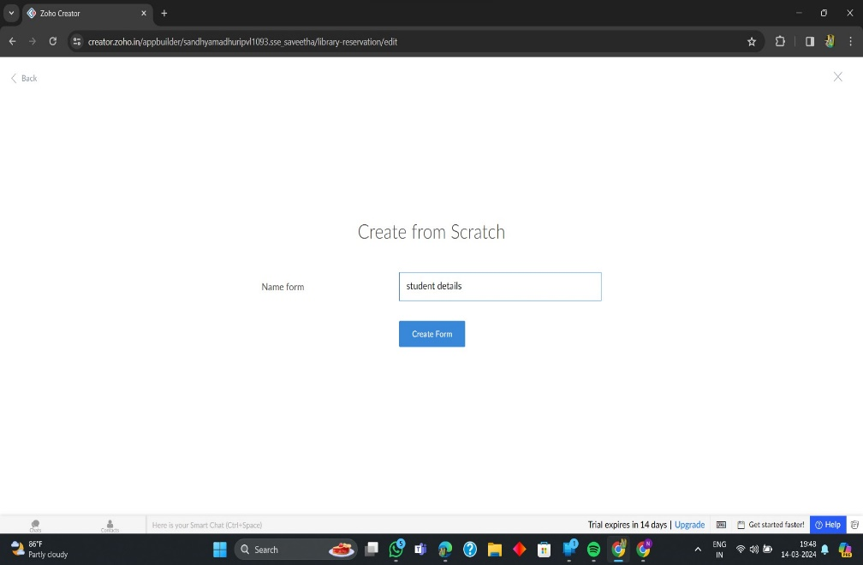

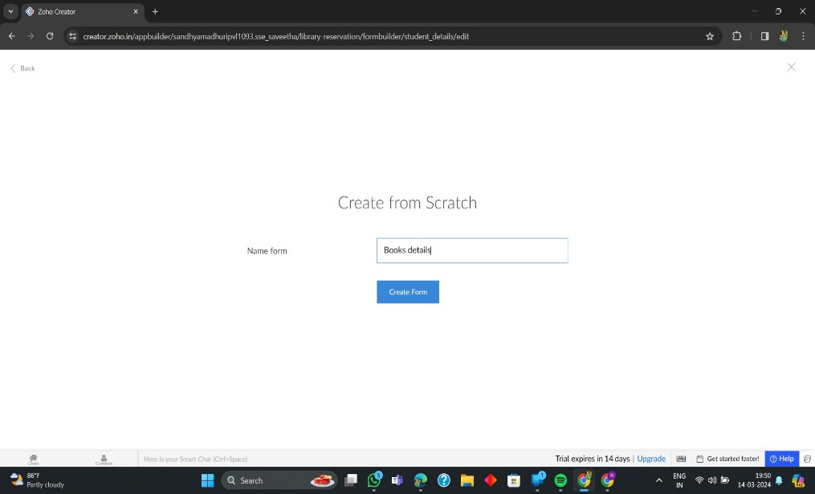

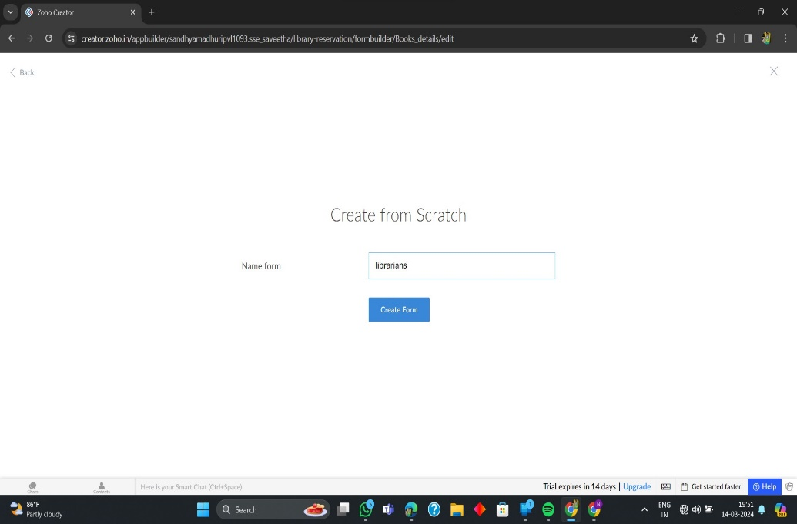

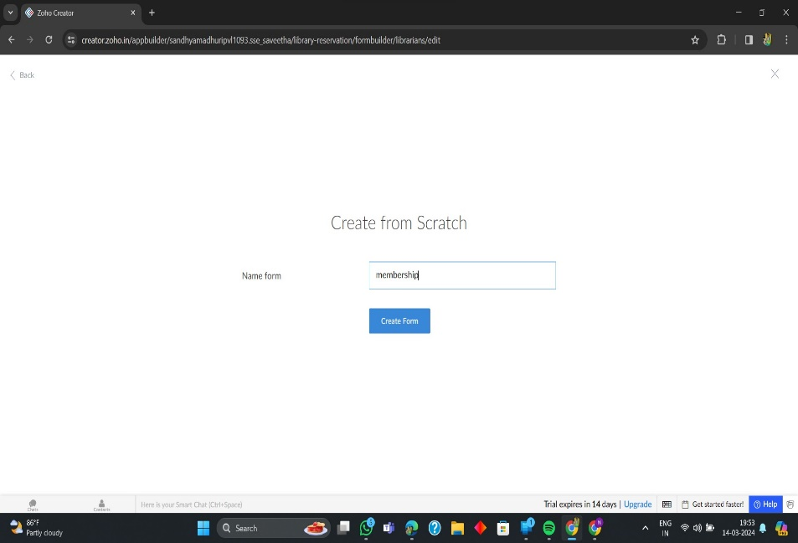

**8. The Software Has been created**

